**Revision History**

|  |  |  |  |
| --- | --- | --- | --- |
| **Version** | **Date** | **Status** | **Revision Description** |
| **0.1** | **14th Oct 2020** | **Draft** | **Document Template Creation** |
| **0.2** |  | **Complete** | **Document Update** |
|  |  |  |  |

**Table of Contents**

**1 Purpose of the document**

**2 Contact information**

**3 Pre-Requisites**

3.1 Summary

3.2 Backups/ Data protection

3.3 Installation of tools and/or software if any

**4 Deployment Instructions**

4.1 Stopping services / Taking Application offline

4.2 Database deployment steps

4.3 Configure the Application in IIS

4.4 Restart services / Bringing application online

4.5 Smoke Testing

4.6 Misc. / Other Details

**5 Roll back Instructions**

**6 Appendix**

6.1 Infrastructure, Application, Smoke-Testing Reference details

6.2 Architecture Diagram

6.3 Release Notes

**1.Purspose of the document**

Purpose of this document is to provide deployment instructions for SNI Application name details

**2. Contact Information**

|  |  |  |
| --- | --- | --- |
| **Name** | **Team** | **Email** |
| Apps Team DL | SNI- AppsCloudPreMigration | SNI-APP-CloudMig@hcl.com |
| 1st Level Escalation | Dharmendra Singh | dsingh@hcl.com |
|  |  |  |

**3.Pre-Requisites**

3.1 Summary

Application Details

**3.2 Backups/ Data protection**

**On-Premise Box:**

1. Take the snap or be open on premise box how it is configured currently. Check the DB connectivity (if it has) and check it should be up & running.

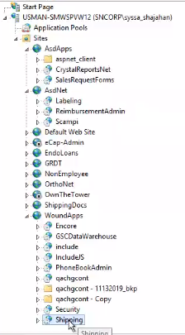

**Azure VM Box:**

1. Take the back up of installable build software packages in ZIP format from on-prem and place it into the Azure VM Box.

**Ex: D:\Backup10142020\SNID**

1. Check in Server Manager whether all required Roles & Features are added or not

Ex: Webserver(IIS), App Development tools (ASP,ASP.NET etc.), ISAPI Filter Extensions, Protocols(HTTP) etc.

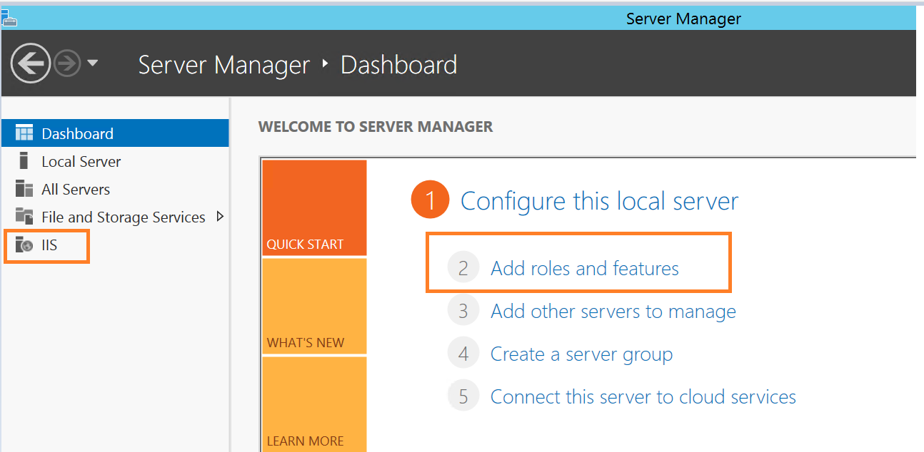

**Reference :** [**https://www.guru99.com/deploying-website-iis.html**](https://www.guru99.com/deploying-website-iis.html)

**4 Deployment Instructions**

**4.1 Stopping services / Taking Application offline**

Stop IIS using the IISReset command-line utility

1. From the Start menu, click Run.
2. In the Open box, type cmd, and click OK.
3. At the command prompt, type

iisreset /stop

1. IIS attempts to stop all services.

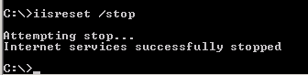

Extract the installable software package folder from the path

Ex: **D:\Backup10142020\SNID** And place it under the path **C:\inetpub\wwwroot**

4.2 **database deployment steps**

**Reference:** [**https://www.mssqltips.com/sqlservertip/5255/learn-how-to-migrate-a-sql-server-database-to-sql-azure-server/**](https://www.mssqltips.com/sqlservertip/5255/learn-how-to-migrate-a-sql-server-database-to-sql-azure-server/)

**4.3 Configure the Application in IIS**

**Open IIS Manager:**

1. Enter the string 'inetmgr' which is the command for IIS.
2. Then Internet Information Services Manager will come up. Click on this.

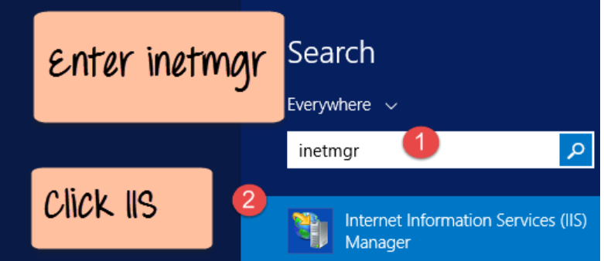

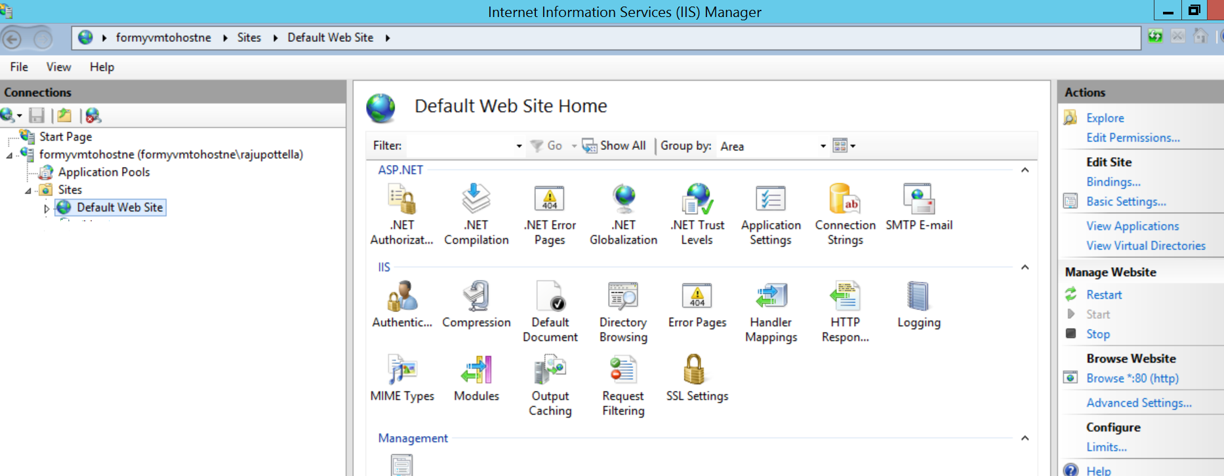

Create Necessary Application Pools with the same configurations as on-prem IIS App Pools

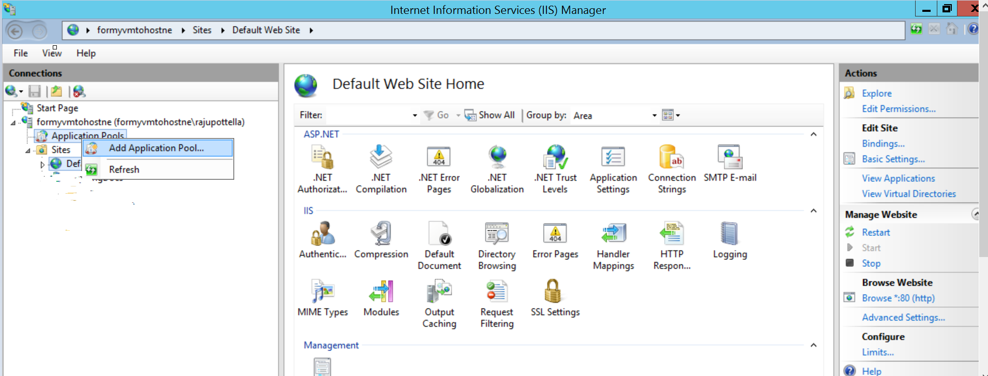

Create a website from application pool by right click on appropriate app pool🡪Add Application--> Give necessary bindings/port numbers as like On-Prem box.

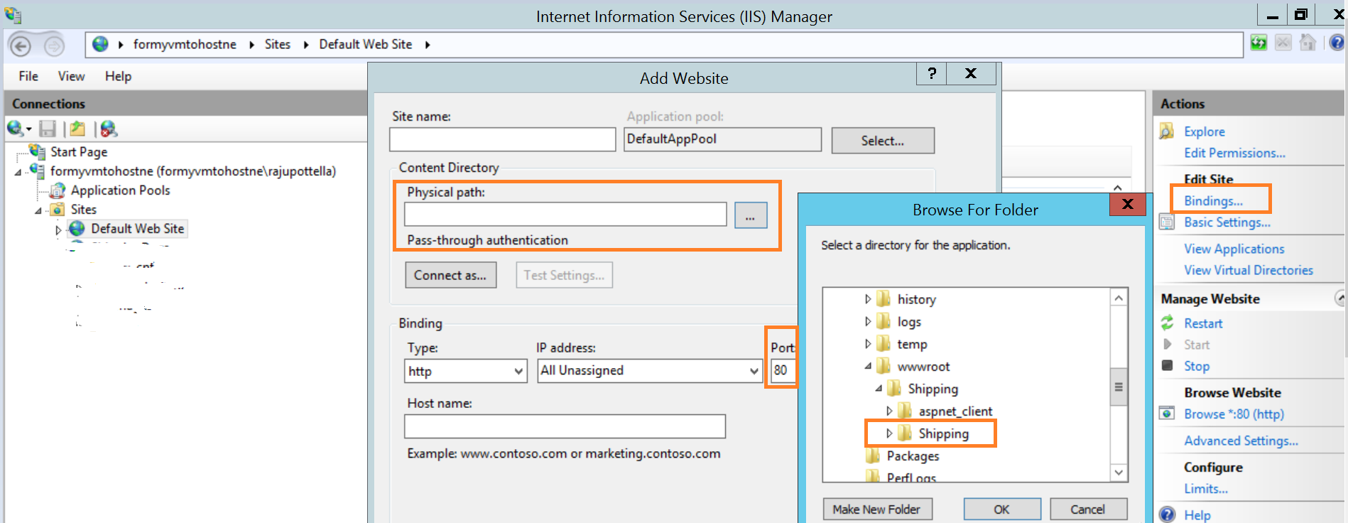

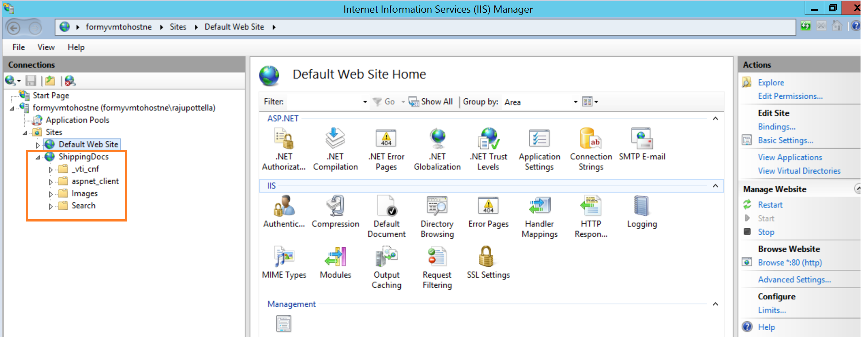

Select proper Default ASP page in order to see the first page when users click on the website url as below.

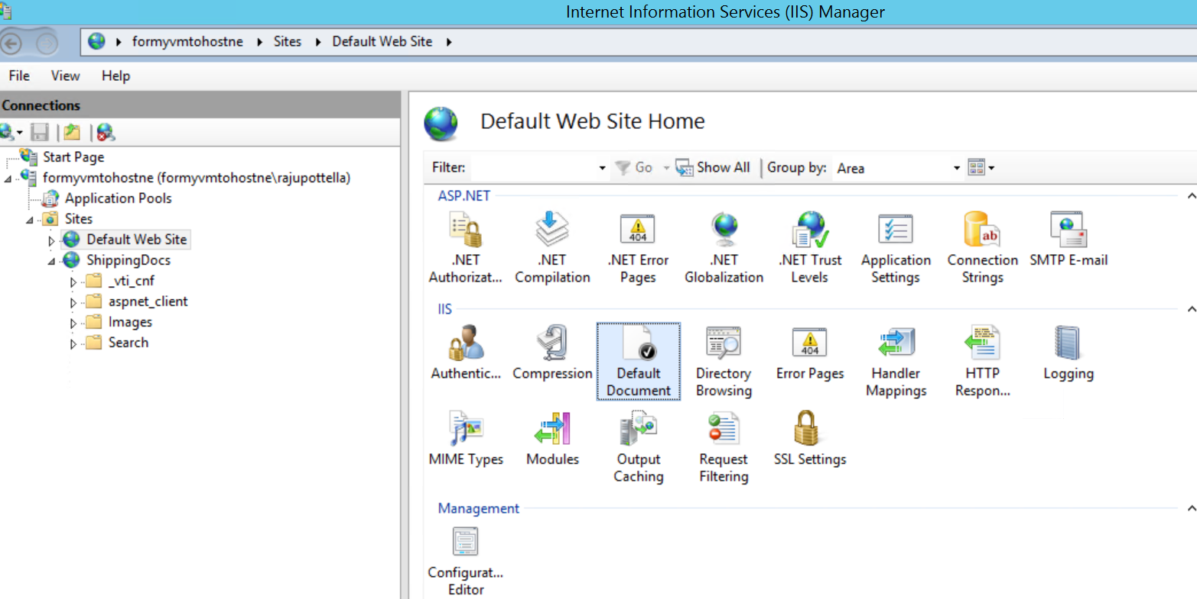

You can move up/down option you can place default asp page.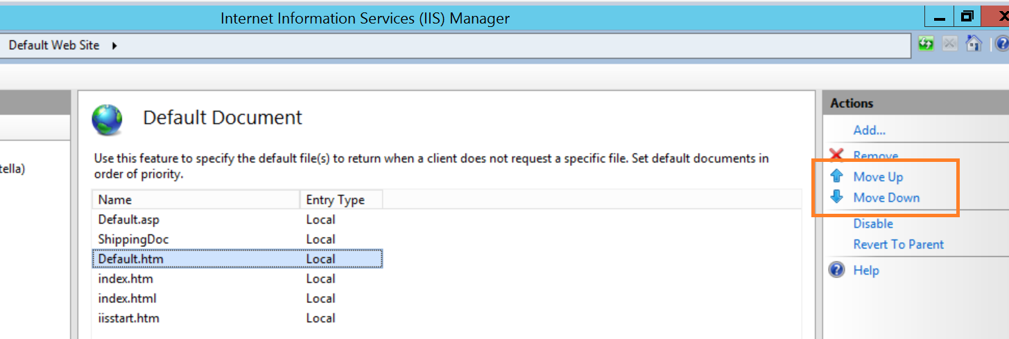

4.4 **Restart services / Bringing application online**

Start IIS using the IISReset command-line utility

1. From the Start menu, click Run.
2. In the Open box, type cmd, and click OK.
3. At the command prompt, type

iisreset /start or iisreset+Enter

1. IIS attempts to start all services.

**4.5 Smoke Testing**

Perform basic website functional testing whether all the buttons, labels, Tabs are functioning as expected.

Needs to process some sample data in to the application and checks whether it is extracting same as earlier on-premise outcome.

Perform some sample data feed operations which end users are being used currently.

**5 Roll back Instructions**

IF the application is not working or getting some error messages while viewing or browsing the url, just act accordingly based on the error message and remove the web application from pool if necessary, re configure it again.

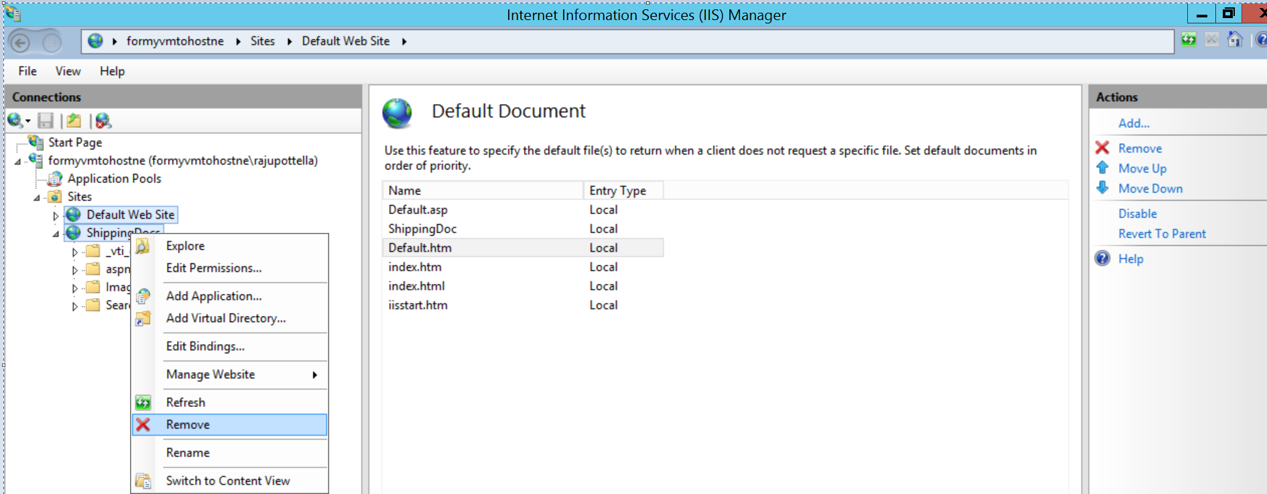

**Known Issues:**

MIME Types needs to be added/Removed

Directory configuration needs to properly selected.

Port numbers duplications.

**6 Appendix**

6.1 Infrastructure, Application, Smoke-Testing Reference details

6.1.1 Application URL

6.1.2 Load Balance